**CHAPTER 1**

**INTRODUCTION**

**1. Introduction:-**

Electricity saving is the major topic to be considered for study. Still in rural areas load shading problem frequently disturbing the framers daily need. So in order to cope this situation we must save the electricity whether it may be on large scale or on small scale. Surveying says that most of the electricity is wasted because keeping the electrical appliances on when they are not in use. If this is the case in case of institutes colleges offices then it may cause a huge loss of electricity.

**1.1 Existing system:**

A system containing a circuitry exists. For example a circuit connected to the MSEB connection so to provide the electricity.

It contains:-

1. Wires
2. Transformers
3. Electric board

**1.2 Proposed system:**

Existing circuit would be experiencing a new change i.e calibration of ultrasonic sensors,esp8266.

Advantages of existing system:

* Energy saving
* Electricity supply according to people
* Full Automize system
* Smart control of electricity.

**1.3 Problem statement**

Save electricity by using ultra sonic sensor and esp8266 circuit which will sense the presence of human

and supply the electricity as per the count of human in the room .which will ultimately save electricity by

turning on necessary number of electrical appliances according to count of human in the room.

The whole system will shut down by app it self

**1.4 Literature Review**

1. Preeti Dhiman 2001 studied “IOT”The colossal measure of electrical energy of numerous nations is devoured in lighting the streets. In any case, vehicles go with low rate in particular timeframes and parts of the streets are not possessed by vehicles after some time. In this paper, we propose a framework that consequently turns off the light for the parts of the roads having no vehicles and turns on the light for these parts once there are a few vehicles that will come. It represents the road light shining framework on vehicle recognizing development. Controlling of road light is of most extreme significance in creating nation like India to decrease the power utilization. Coherently, this framework may spare a lot of the electrical power. Furthermore, it might expand the lifetime of the lights and decrease the contamination level. This framework consequently controls and screens the light of the boulevards. It utilizes sun based vitality put away amid the day to control the LEDs amid the night. Ultrasonic Sensors utilized on either sides of the street send rationale summons to the microcontroller for exchanging on the LEDs.
2. Baharuddin Mustapha1,Aladin Zayegh,Rezaul K. Begg (2006) Ultrasonic (US) and infrared (IR) sensors arebroadly used in mobile applications for distance measurements.In this project, an obstacle detection system is built based onthese two types of sensors. The system is intended for use by the elderly and people with vision impairment. The prototype developed has been tested to detect obstacles and shows accuracies of 95% to 99% for distance measurements if the sensor circuits are calibrated properly and their output linearized. The system also demonstrates good detection for different obstacle materials (e.g., wood, plastic, mirror, plywood and concretes) and colors. The minimum size of an obstacle that the system can detect is 5 cm x 5 cm.
3. Mamta B. Rajgor “Automation: A New Millennium Technology for Construction Industries” 2013 Building and construction industries are one of the major industries around the world. In which Construction industry is a labour intensive. It is conducted in dangerous situations. So, the importance of construction robotics has grown rapidly. Applications and activities of robotics and automation in construction industry started in the early 90s aiming to optimize equipment operations, improve safety, enhance perception of workspace and furthermore, ensure quality environment for building occupants. Construction automation is a broadly defined planning and technical endeavor that includes in distinct areas .It is the development of programmable (i.e., robotic) hardware for the execution of construction work tasks; significant progress has been achieved in equipment navigation systems. It is also the development of computer-based tools for efficient and optimal planning, design, construction, and execution for construction. The main goal of this paper is to convince building designers and managers to incorporate robotic

systems when managing modern buildings. This paper studies recent applications for robots and automation in the construction industry and sets opportunities and challenges through a new framework for better planning and control of construction equipment operation. In this paper, Studying recent applications and projects for using robots and automation in the construction industry, Setting opportunities and rapidly and also provides a new tool for addressing large-scale and complicated field problems.

**1.5 Scope**

* It will indicate the how much electric used per day on mobile.
* Whole system will be shut down by single click on mobile.
* That much electricity will be supplied which needed for people in room.

**CHAPTER 2**

**AIM AND OBJECTIVE**

**2.1 Aim**

To save electricity by automizing classroom.

**2.2 Objective**

This project will help in saving electricity and it makes building smart.

1. To provide best automized Classroom with saving Electrticity
2. To provide a cost efficient smart system .
3. To apply knowledge of app developing .

**CHAPTER 3**

**METHODOLOGY**

**3.Methodology**

**T**he methodology will be adopted as follow:

1. Ultra sonic sensor keep sensing change in the distance .
2. If there is change in predefined distance of ultra sonic sensor then it will tell esp8266

To load the program of turning on electrical appliances according to the distance.

1. If there is no change then system will remain turn off .
2. In case if lights remain on then whole system can be shutdown by clicking off button on mobile.

**3.1 Implementation Details**

1. Ultra sonic sensors will be set at certain distance above ground or floor level of building so that it will sense only heighted objects like human.
2. The program of turning on the light appliances according to position of human in room is stored in esp8266
3. which is connected to ultra sonic sensors and light appliances .
4. when any human enters in the room then it will come in the range of ultra sonic sensors and then there will be change in the predefined distance of ultra sonic sensors.
5. If change occurs then light in that area where the change in distance has occurred will glow.

**3.2 Coding Pages:**

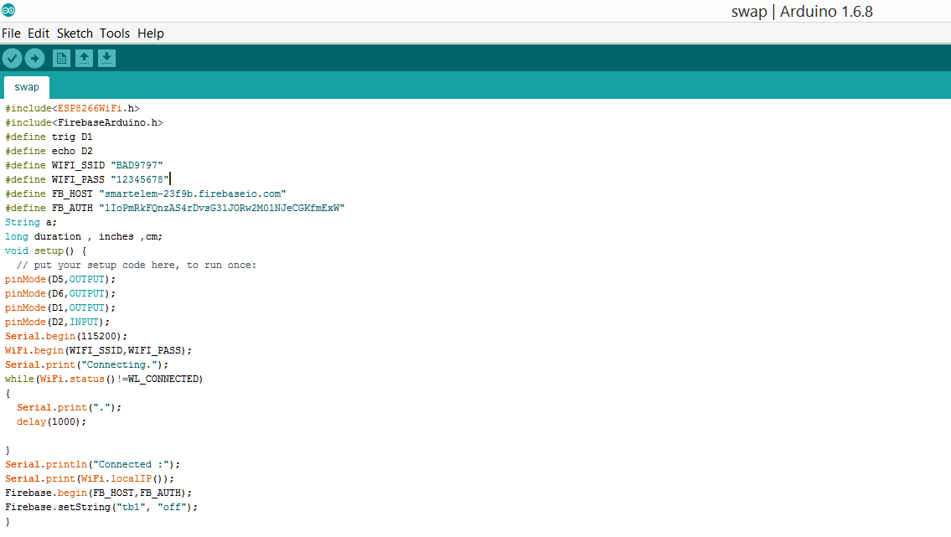

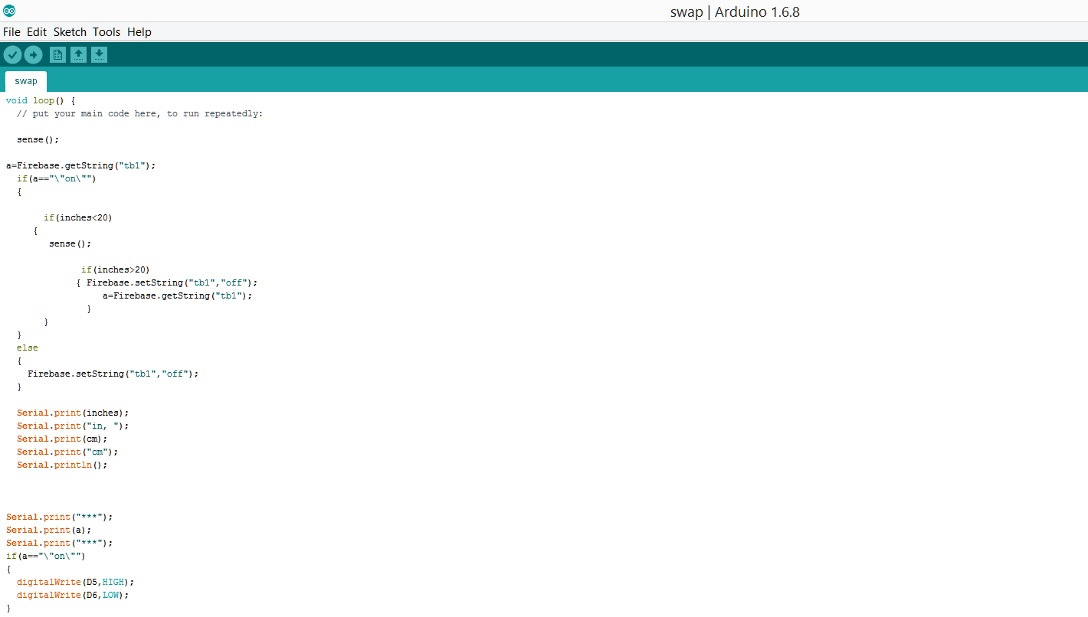

**Fig 3.2: Login**

**CHAPETER 4**

**RESULT AND DISCUSSIONS**

**Screen shot :-**



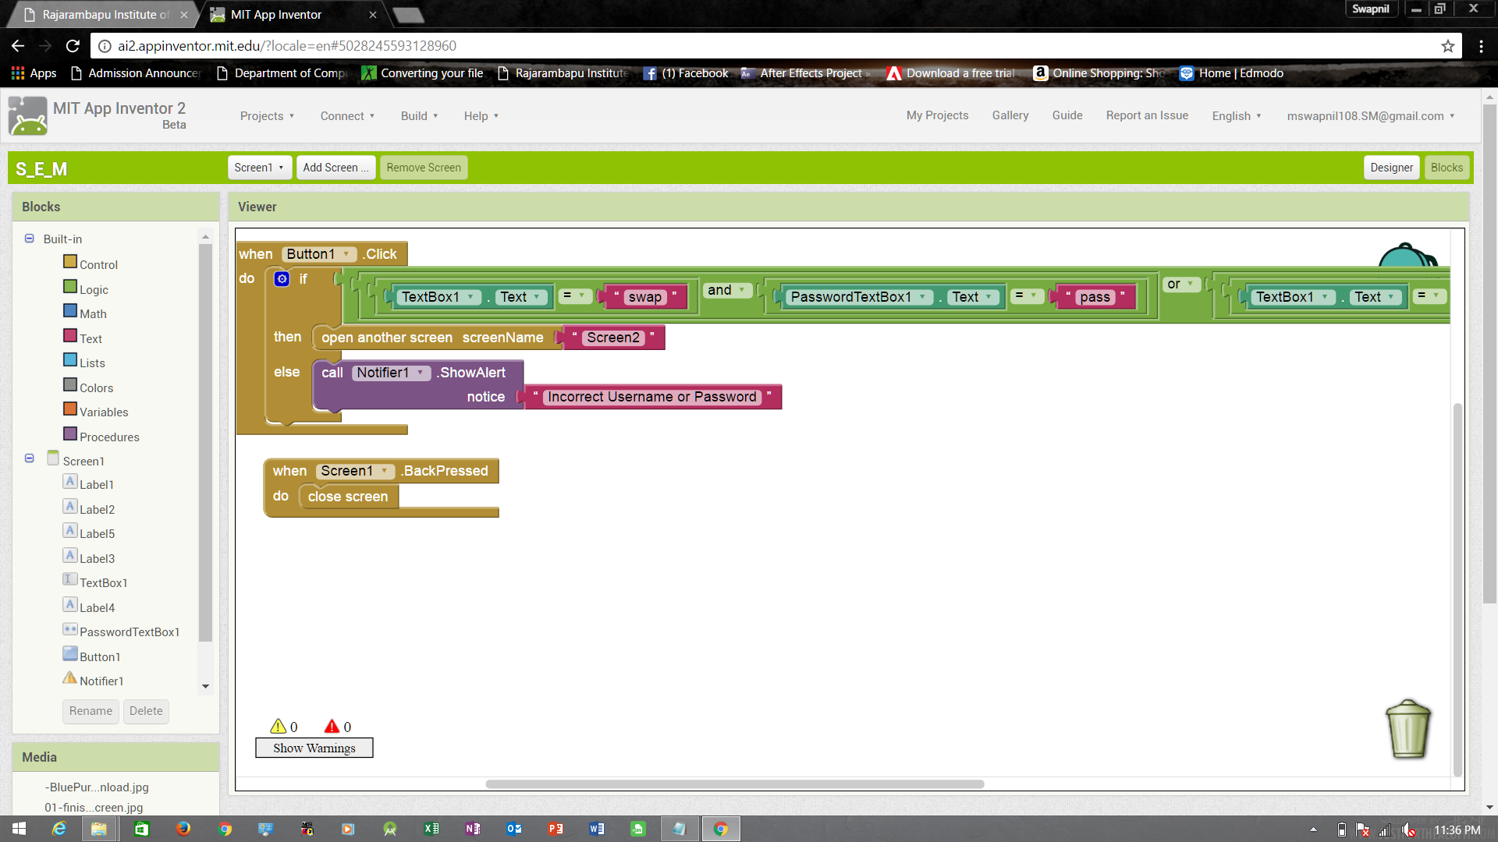

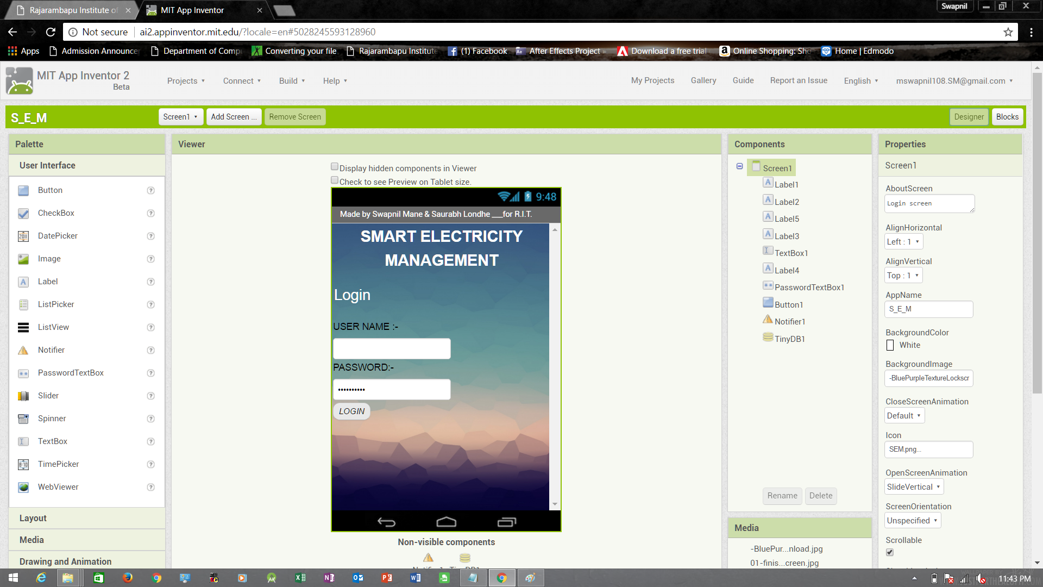

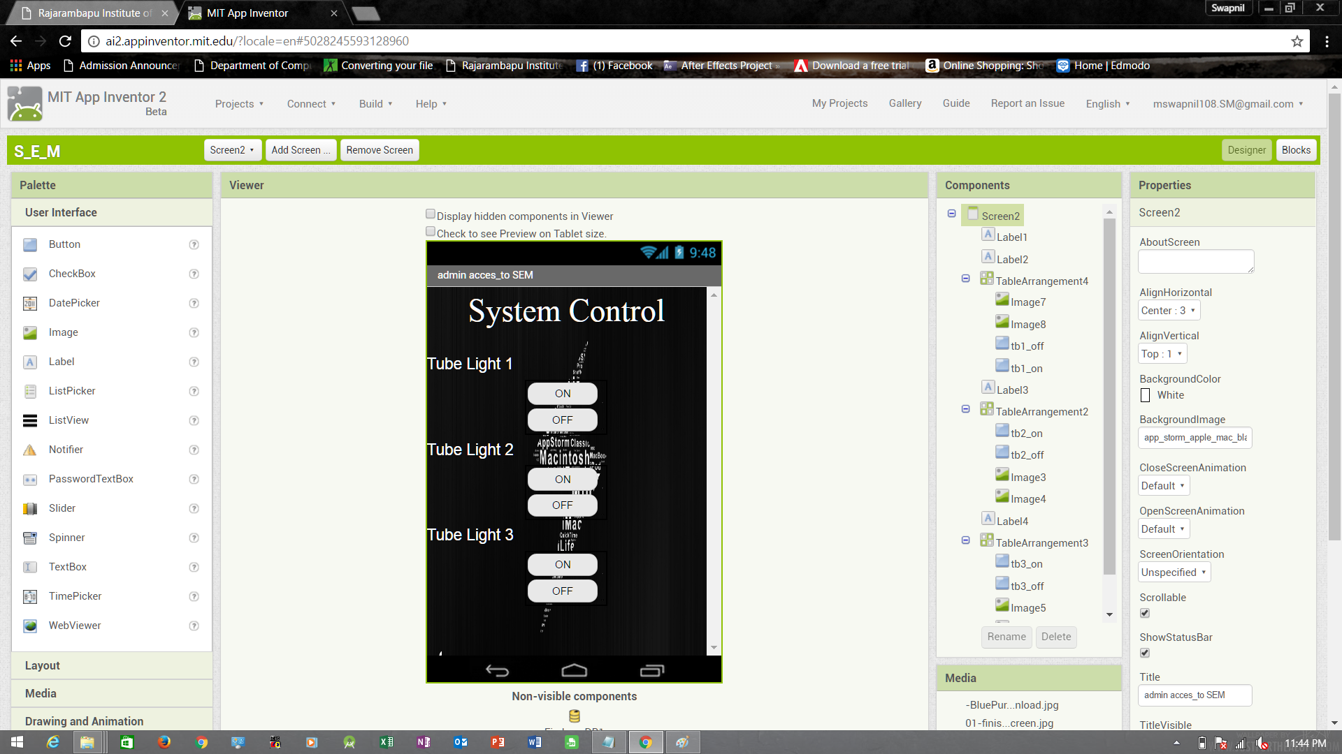

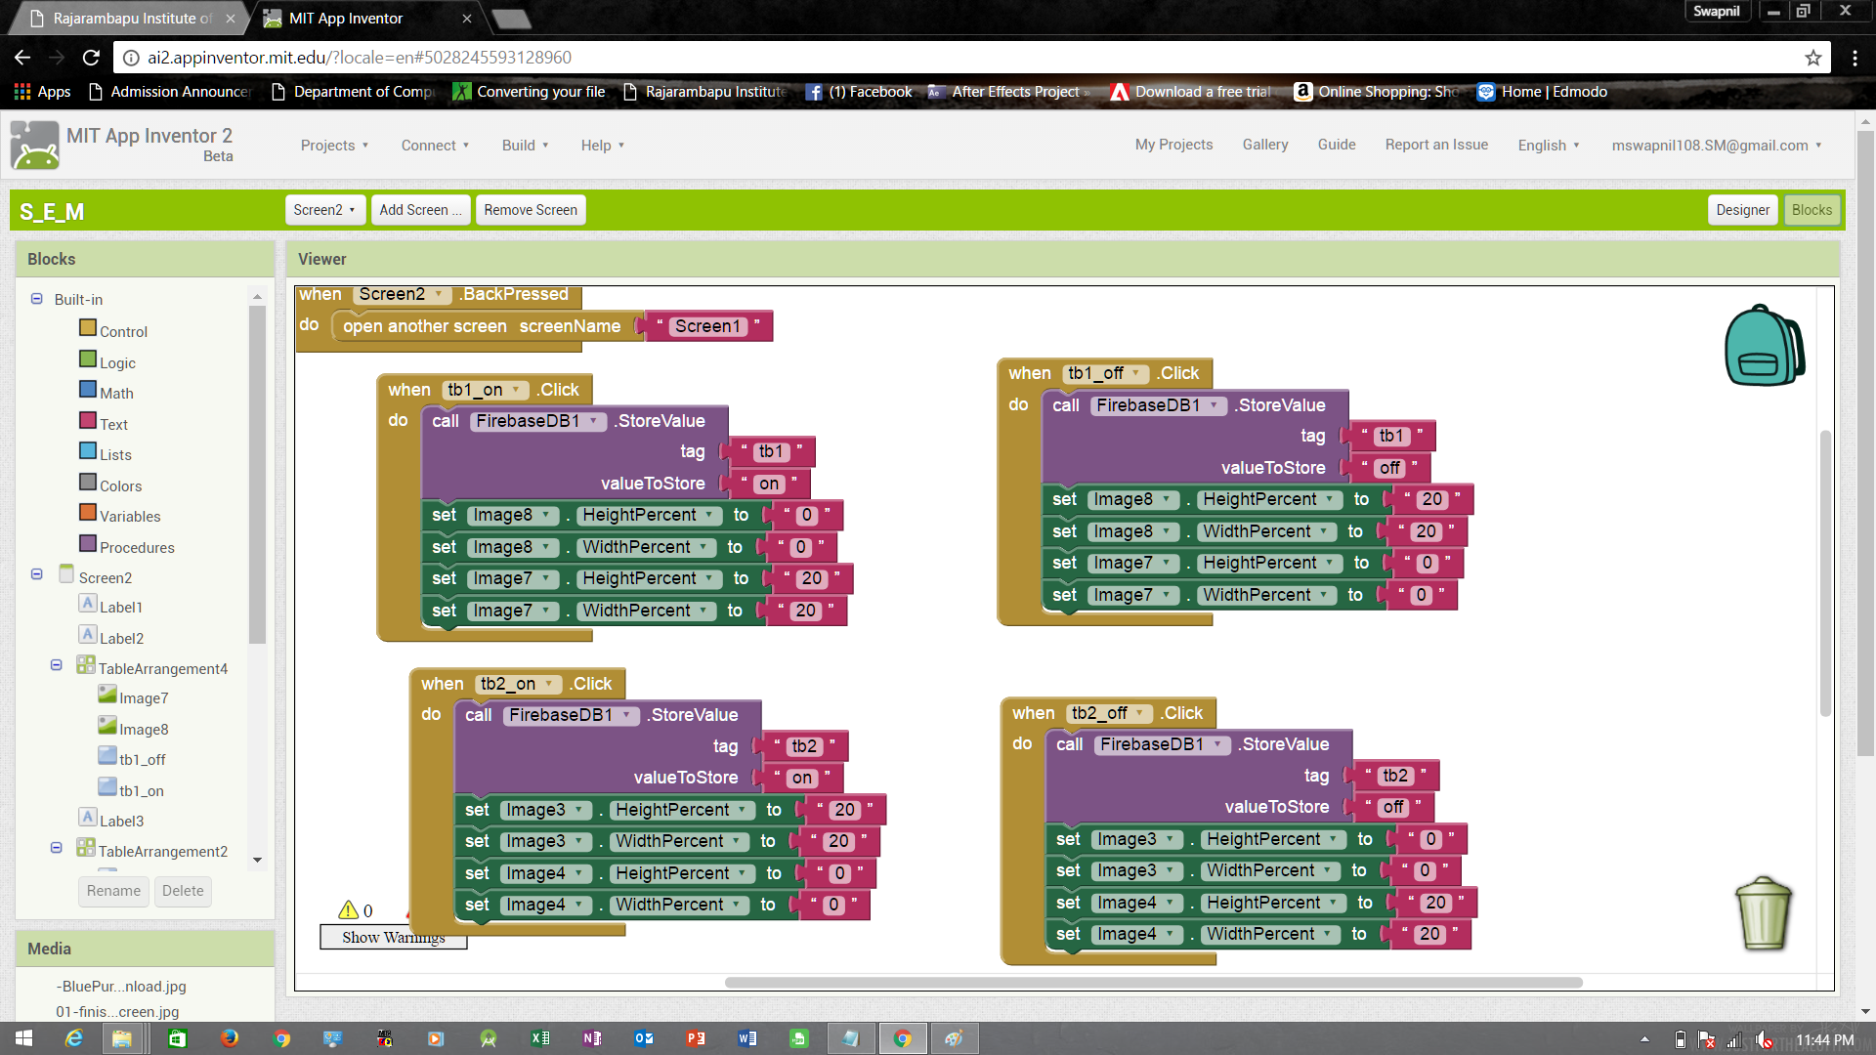

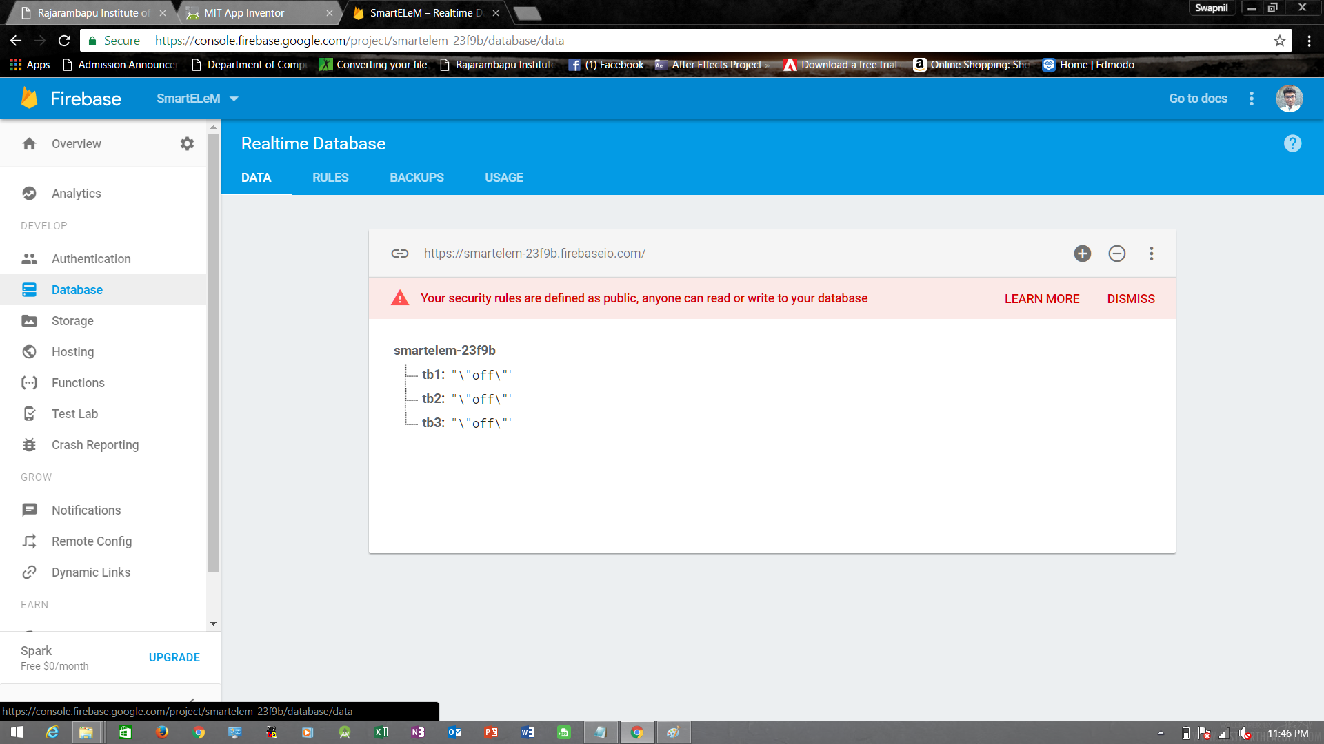



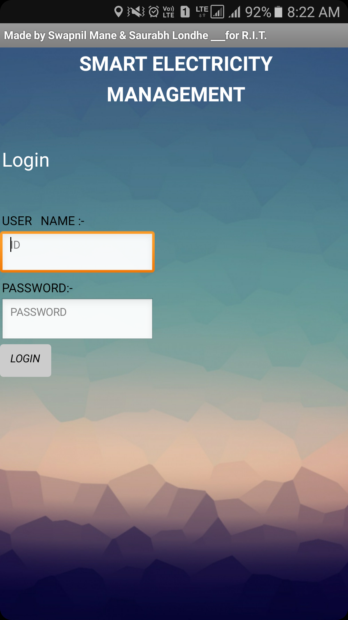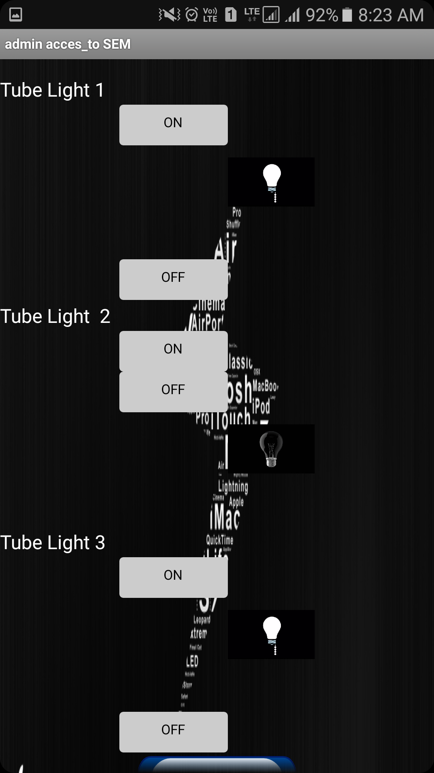

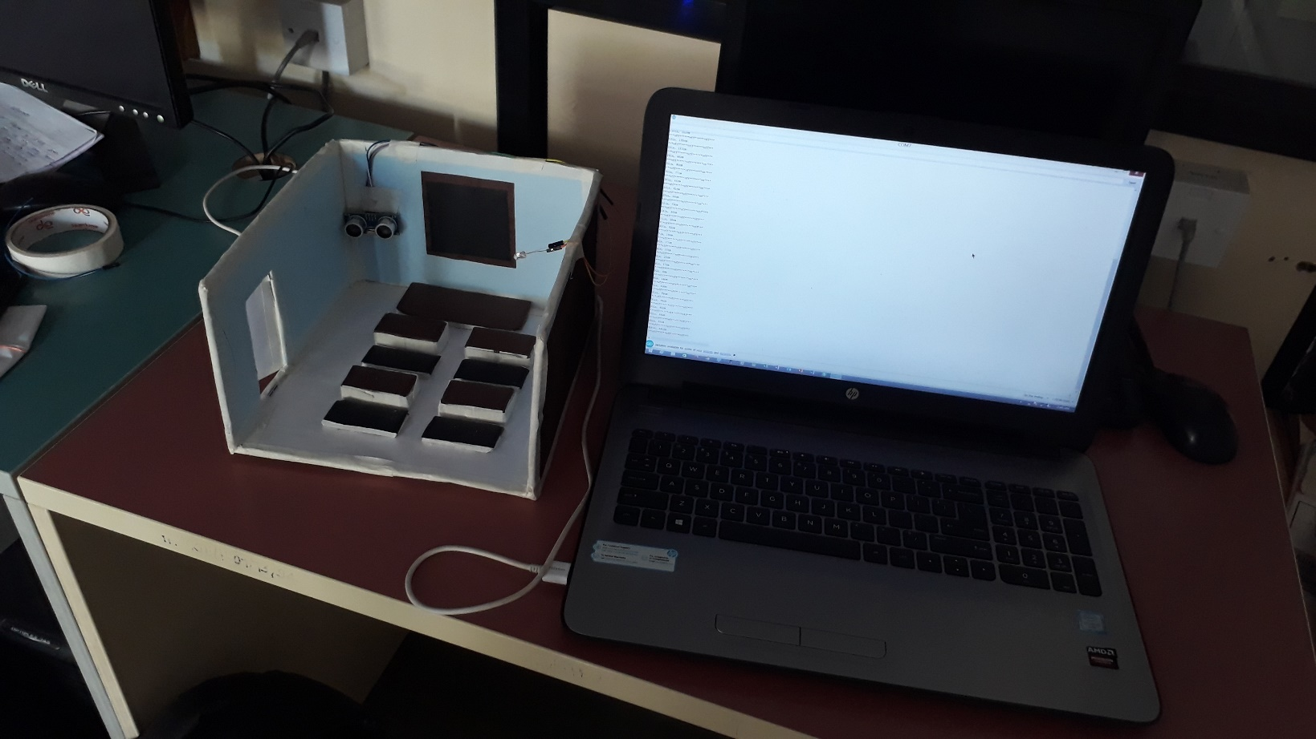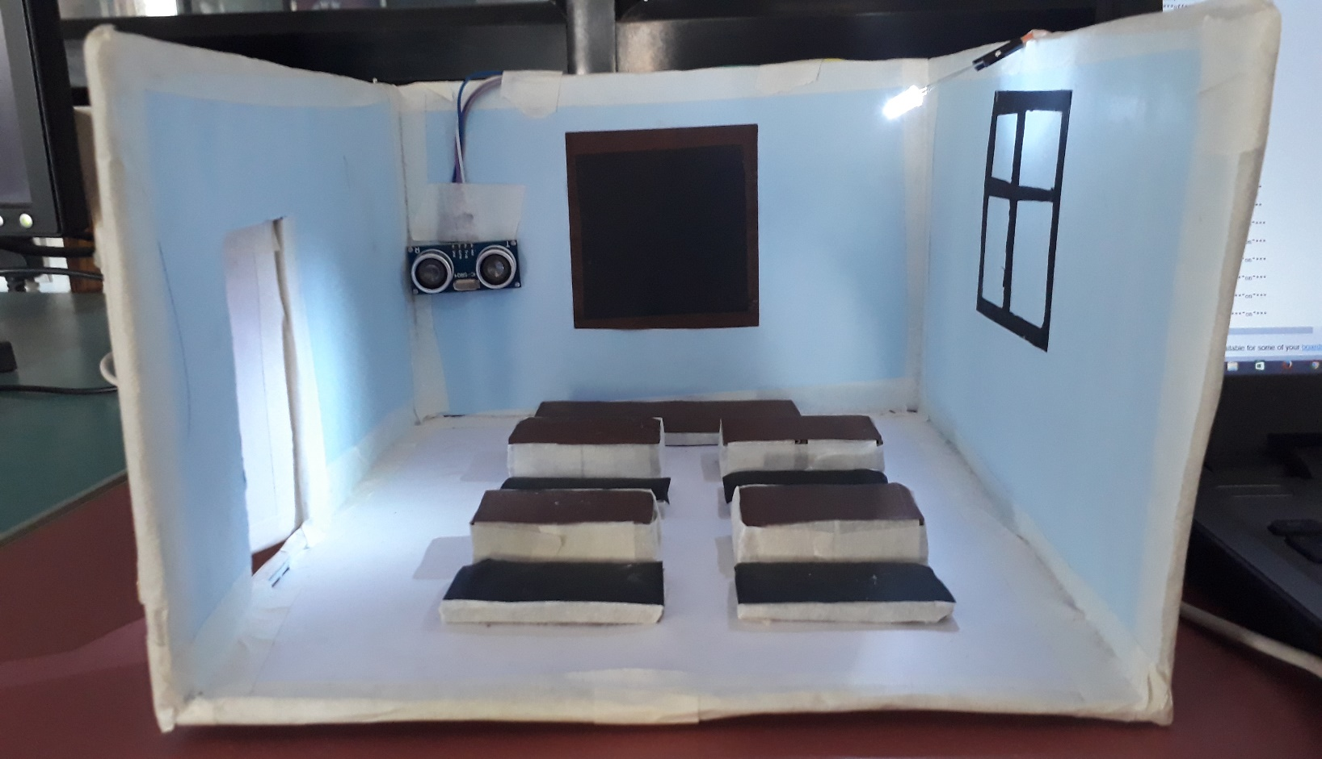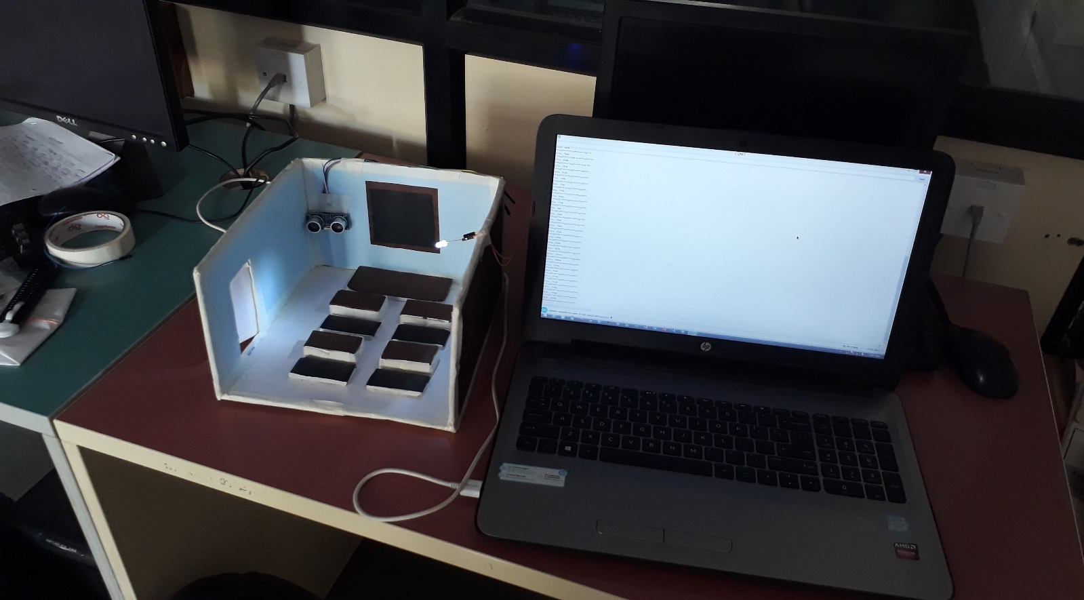

**CHAPTER 5**

**CONCLUSION**

**5. Conclusion**

* **We can save electrical energy as we use the project methods effectively.**
* **This project will be a step forward to the near future of automization and energy conservation.**
* **People will study the use of application based electricity control through automization methods.**
* **This project will meet the needs less human efforts and quick access to electricity without reaching the destination key switch.**

**CHAPTER 6**

**FUTURE SCOPE**

**6.Future work**

**Growth in Automation Market in India (2018-22)**

The next phase for the Home automation market will occur based on a few key improvements in the technology available in Automation, such as improvement in Wireless Automation solutions as well as lowering of price points as the market begins to accept Home automation usage in larger volumes. Some trends that we foresee for this phase of the industry are

• Big companies like Philips, Siemens & Schneider will eventually bring out fairly mass market automation products with appealing user interface but at a lower price point than today, and more people will be able to afford the products  
• Solution offerings will slowly move to a more user friendly design, where aside from a few key components, users will be able to buy and use the Automation products themselves without the aid of any technical expert  
• Some foreign players will have niche in high end automation and focus on the premium market (>20 Lakh ticket size).

**Commodification of Automation market (2021 onward)**

As with any industry, as Automation for residences become common place, the market will eventually be crowded with several players, multiple product offerings and competitive pricing. The market for just Home automation is estimated to be 3.2$ Billion by 2020. If IoT were to become common place, then we’re looking at a multi-billion dollar opportunity in the Indian market.

* We foresee that all major players will have a presence leading to competition in prices and lower margins
* The products themselves will reach a ‘**plug and play’**type of usability, where users can simply purchase pieces from the store and use it themselves without any support from professionals
* Many (most) houses will incorporate some aspect of Automation in the home, from Lighting, security or HVAC elements. Home Automation will be as commonplace as having a Fridge or Television in the house.

**CHAPTER 7**

**REFERENCES**

**7. References**

[1] S. K. Cho and V. Dhingra, “Street Lighting Control Bas- ed on LonWorks Power Line Communication,” IEEE In-ternational Symposium on Power Line Communications and Its Applications, Jeju City, 2-4 April 2008, pp. 396- 398.

[2] Schwab, R.N., Walton, N.E., Mounce, J.M., and Rosenbaum, M.J. (1982) Synthesis of Safety Research Related to Traffic Control and Roadway Elements-Volume 2, Chapter 12: Highway Lighting. Report No. FHWA-TS-82233. Federal Highway Administration.

[3] Elvik, R. (1995) “Meta-Analysis of Evaluations of Public Lighting as Accident Countermeasure.” Transportation Research Record 1485, TRB, National Research Council, Washington, D.C., pp. 112-123.

[4] A New Millennium Technology for Construction Industries

Volume : 2 | Issue : 2 | Feb 2013 • ISSN No 2277 – 8160 Automation and Robotics in Construction: Opportunities and Challenges by S.M.S Elattar